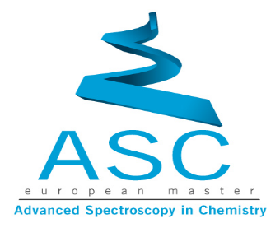
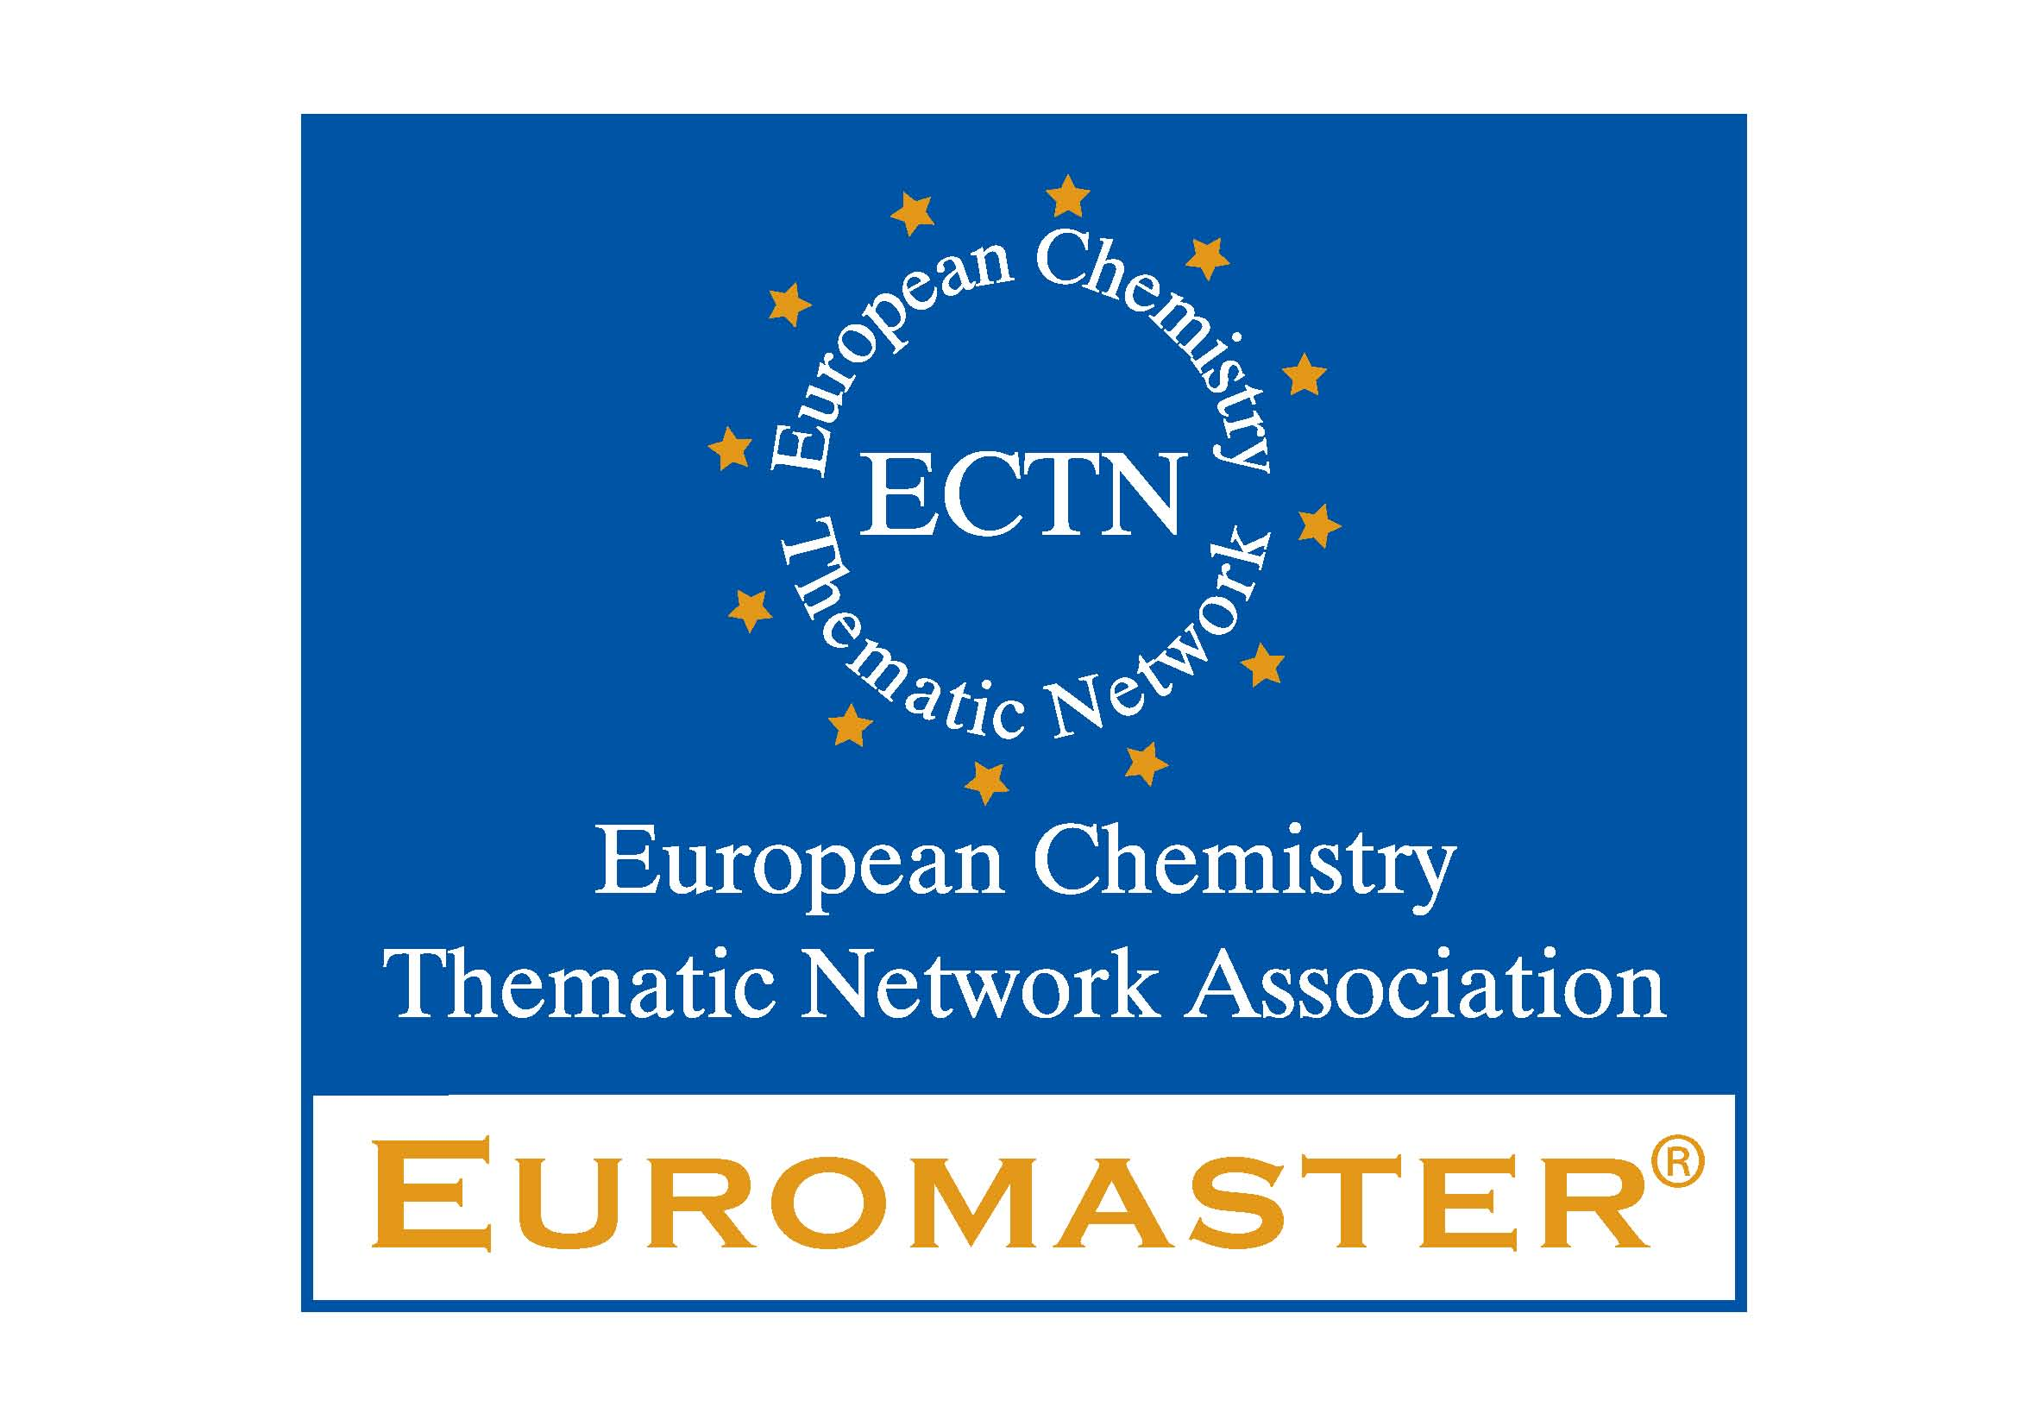

Erasmus Mundus Master Course in
“Advanced Spectroscopy in Chemistry”

EM Scholarships available for European and International students

Since 2008, the European Commission awards scholarships to European and international students (500 euro per month during the whole duration of the programme) for attending the now well recognised « Erasmus Mundus » Master courses, among which is the Master in "Advanced Spectroscopy in Chemistry" .

Selected non-European students will even get 1000 € per month.

The deadline for applying is January 15th 2012 for entering the course in September 2012.

You will be studying in at least 2 of the following institutions:
Jagiellonian University Krakow, Poland
University of Bergen, Norway
Alma Mater Studiorum University of Bologna, Italy
University Lille1, France
Complutense University of Madrid, Spain
University Leipzig, Germany
University of Helsinki, Finland
And receive a multiple MSc degree
Find more about and apply to ASC programme: www.master-asc.org
Find more about Erasmus Mundus: http://eacea.ec.europa.eu/erasmus_mundus/index_en.php



